9 Day Classic Namibia Adventure

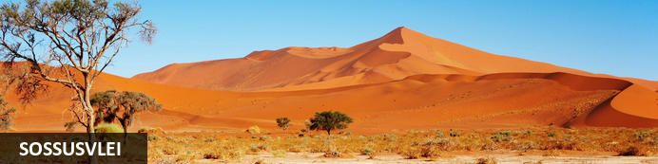
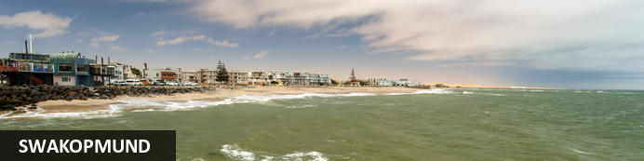
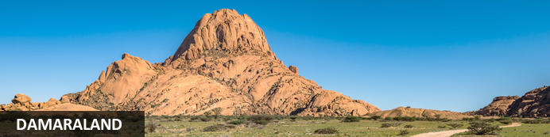
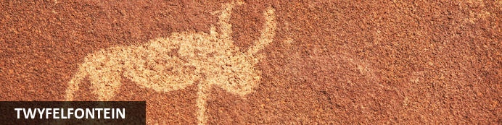
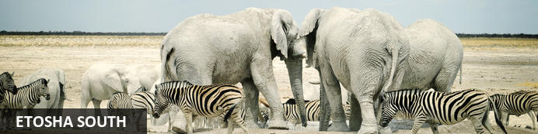
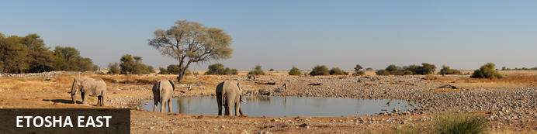

9 Day Classic Namibia Adventure
Sossusvlei - Swakopmund - Damaraland - Twyfelfontein - Etosha South - Etosha East
9 Days / 8 Nights
2 Persons
Date of Issue: August 24, 2021

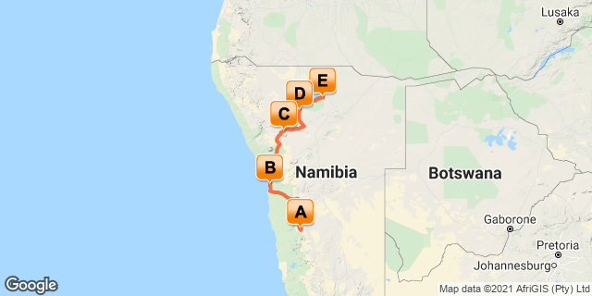

Click here to view your Digital Itinerary

Introduction
Desert dunes, ghostly shores and remarkable wildlife; this 9-day tour takes in Namibia’s showstopper highlights.
Highlights:
Sossusvlei Sand Dunes
Walvis Bay and Swakopmund
Twyfelfontein Paintings
Damara Living Museum
Etosha National Park

Start | Accommodation | Destination | Basis | Room Type | Duration
Day 1 | Elegant Desert Lodge | Sossusvlei | B&B | 1x Twin Room | 2 Nights
Day 3 | Hansa Hotel | Swakopmund | B&B | 1x Standard Room | 2 Nights
Day 5 | Damara Mopane Lodge Gondwana Collection Namibia | Damaraland | B&B | 1x Standard Twin Room | 1 Night
Day 6 | Etosha Safari Camp Gondwana Collection Namibia | Etosha South | B&B | 1x Standard Twin Rooms | 1 Night
Day 7 | Mokuti Etosha Lodge | Etosha East | B&B | 1x Standard Room | 2 Nights

Key
B&B: Bed and Breakfast

Included
Accomodation and meals as per package, bottled water on board the vehicle, transport, entrance fees and sightseeing as specified.

Excluded
Any service not specified.

Day 1: Elegant Desert Lodge, Sossusvlei

Namibia
Namibia posesses some of the most stunning landscapes in Africa, and a trip through the country is one of the great road adventures. Natural wonders such as that mighty gash in the earth at Fish River Canyon and the wildlife utopia of Etosha National Park enthrall, but it’s the lonely desert roads where mighty slabs of granite rise out of swirling desert sands that will sear themselves in your mind. It’s like a coffee-table book come to life as sand dunes in the world’s oldest desert meet the crashing rollers along the wild Atlantic coast. Among all this is a German legacy evident in the cuisine and art nouveau architecture, and in festivals such as Windhoek’s legendary Oktoberfest. Namibia is also the headquarters of adventure activities in the region, so whether you’re a dreamer or love hearing the crunch of earth under your boots, travel in Namibia will stay with you long after the desert vistas fade.

Sossusvlei
Sossusvlei is where you will find the iconic red sand dunes of the Namib. The clear blue skies contrast with the giant red sand dunes to make this one of the natural wonders of Africa and a photographers heaven. Aside from the attractions at Sossusvlei - Dune 45, Hiddenvlei, Big Daddy and Deadvlei - other attractions in the area include the Sesriem Canyon and Namib-Naukluft National Park, where the mountains of the Namib meet its plains.

Day Itinerary
Departing Windhoek, we travel to our lodge in the Namib Desert. This is the gateway to Sesriem Canyon and Sossusvlei, where some of the highest sand dunes on Earth stand towering over the white desert plains. The afternoon can be spent relaxing at the pool, or taking part in optional activities offered at our lodge.

Overnight: Elegant Desert Lodge View iBrochure
The Elegant Desert Lodge
Soulful, liberating and elegant
Situated on the border of the World Heritage site of the Namib Desert and only 37 kilometers from the gate to Sossusvlei, the Elegant Desert Lodge offers accommodation in 29 tastefully furnished, air conditioned rooms. All en-suite, the stylish and comfortable rooms invite you to recline in the soulful yet liberating atmosphere of the world’s oldest desert.
A beautiful and tranquil garden offering various, innovative seating arrangements inspire an image of an oasis nestled in the Namib Desert. Alternatively, enjoy the vistas of the desert plains from the veranda of your room. We suggest you treat yourself to a casual lunch with a bottle of fine South African Wine, each handpicked by the owners. In the afternoon you can relax in one of our chic lounges in the gardens or at the sparkling pool, or you can participate in the Scenic drive with spectacular views overlooking the Namib Desert.
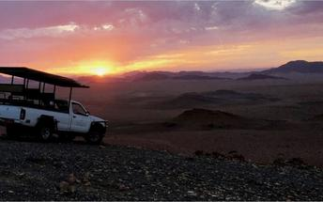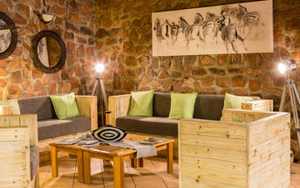

Twin Room
25 Double rooms & 4 x Four Bed Family Units, tastefully furnished with en-suite bathrooms, equipped with air-conditioning & Tea and Coffee Station
24 hour wireless internet access - free of charge! (Only available at Reception)
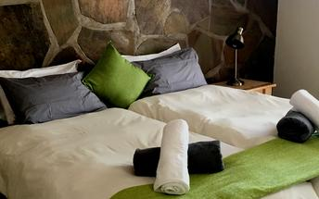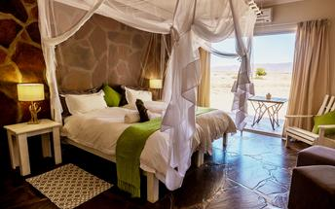

Basis
Bed and Breakfast

Day 2: Elegant Desert Lodge, Sossusvlei

Day Itinerary
The morning demands an early start. Entering the Namib Naukluft National Park with sunrise, the first rays of sunlight paint the mountains of sand into a variety of apricot, red and orange, contrasted against a crisp blue skyline, enrapturing our senses, and providing an opportunity to capture this awesome landscape on film. You will be captivated by the surreal Deadvlei surrounded by some of the highest dunes on earth and Sossusvlei, where the dry Tsauchab River ends abruptly amongst dunes. Take the opportunity to walk up one of these majestic dunes to admire the desert landscape beneath. Thereafter we visit the Sesriem Canyon, a life sustaining natural phenomenon in the heart of the Namib Desert.

Basis
Bed and Breakfast

Day 3: Hansa Hotel, Swakopmund

Swakopmund
Swakopmund, known as Swakop in Namibia is the country's biggest coastal resort and adventure town with a quirky mix of German and Namibian influences. The city's German origins dating back to 1892 are quite pronounced in beautiful old German colonial buildings throughout the city, making an even starker contrast for this town sitting at the edge of the Namib Desert.

Day Itinerary
After breakfast we continue our journey approaching the little settlement of Solitaire on the edge of the Namib Naukluft National Park, feeling like you have arrived in the middle of nowhere. Here it is worthwhile to enjoy a cup of coffee with the delightful apple-pie written about in so many travel books before travelling via the desolate, rolling hills of the Kuiseb Valley towards the Atlantic Ocean. Reaching the coastal harbour town of Walvis Bay, we visit the shallow lagoon, one of the most important wetland areas on the African continent and a RAMSAR World Heritage Site. Over 80% of the African flamingos feed in this lagoon and present a breath-taking picture when they appear in groups. Continuing along the scenic route between the dune belt and the Atlantic Ocean we reach Swakopmund, where the rest of the day is spent at leisure. With palm-lined streets and seaside promenades, Swakopmund is a popular holiday destination in Namibia.

Overnight: Hansa Hotel
Centrally situated, the hotel serves as the perfect getaway to all tourists amenities which Swakopmund and surrounding areas have to offer, from sand-boarding some of the highest dunes in the world to big game viewing in one of our country's world-known game parks. Surrounded by local tour operators, aviation and safari offices and five minutes from the beach, the Hansa Hotel is perfect for the discerning traveler looking for an adrenaline filled holiday or merely a bit of relaxation.
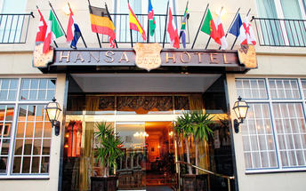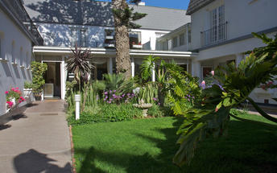

Standard Room
Each room is individually decorated and fitted with under tile or under carpet heating, 15 satellite television/radio channels, direct dialling telephones, hairdryer, safes, coffee/tea facilities and en-suite bath/showers.

Basis
Bed and Breakfast

Day 4: Hansa Hotel, Swakopmund

Day Itinerary
Swakopmund is often referred to as the “playground of Namibia” and it has numerous activities ranging from, adventure to exploring the fascinating features of the Namib Desert and the animals and plants that occur and survive here. Embrace the relaxed pace of this idyllic coastal town whilst enjoying coffee and freshly baked pastries in one of the many cafés. Alternatively explore the rugged, sweltering desert on a day tour, or view this awesome, environment from the air on a scenic flight. Find your inner child and push adrenaline to its limits with extreme adventures such as skydiving over the desert or quad biking and sand boarding on the dunes. Take time to get the feel of this quaint town with its historic buildings, museums, shopping arcades and beach bar that has transformed into its own personality by the vibrant use of colour and the bohemian lifestyle.

Basis
Bed and Breakfast

Day 5: Damara Mopane Lodge Gondwana Collection Namibia, Damaraland

Damaraland
Huge, untamed and ruggedly beautiful Damaraland is an exceptionally scenic landscape of open plains and spectacular rock formations. The major attractions are Spitzkoppe, the Brandberg, Twyfelfontein, Vingerklip and the Petrified Forest.The landscape tough is as impressive as it is intimidating. Rugged mountains in the eastern escarpment spread out into massive valleys and plains, before the beginning of the Skeleton Coast in the west, where endless dunes lie adjacent to the cold Atlantic Ocean.

Twyfelfontein
Set in the Kunene Region of northwestern Namibia, Twyfelfontein is a spectacularly scenic area, featuring one of the largest and most important concentrations of rock art in Africa. The name ‘Twyfelfontein’ translates to ‘Fountain of Doubt’, which refers to the perennial spring situated in the impressive Huab Valley flanked by the slopes of a sandstone table mountain. It was this spring that attracted Stone Age hunters over six thousand years ago, and it was during this time that the extensive group of rock engravings and paintings were produced. Visitors can look forward to basing themselves at some wonderfully shady campsites along the Aba-Huab riverbed, while exploring over thirty different sacred ritual sites of the traditional hunter-gatherer communities.

Day Itinerary
On long yet interesting and scenic roads we head further north, traveling past the Brandberg, Namibia’s highest mountain (2.579m), into the Damaraland, one of the least populated and geologically diverse areas in Africa. This harsh, rocky environment is home to the elusive desert elephant, the black rhino and free-roaming antelope species. Accompanied by a local Damara guide we visit Twyfelfontein, a UNESCO heritage site where Bushman communities engraved and painted over 2.500 pictures some 6.000 years ago! After a visit to the nearby Living Museum of the Damara we proceed to the Petrified Forest - a geological phenomenon depicting the creation and metamorphosis of wood into stone amongst some of the oldest landmasses on Earth. Here we also see the Welwitschia mirabilis plant – the oldest living desert plant on Earth.

Overnight: Damara Mopane Lodge Gondwana Collection Namibia View iBrochure
Damara Mopane Lodge is located 20 km east of Khorixas on the C 39 (Damaraland).
Built in a labyrinth design, this innovative lodge has 55 chalets, each with its own vegetable garden. Savour the charm from your stoep where sunflowers peep over walls, refresh in the pool, visit the Twyfelfontein rock engravings 100km away and watch the sun sink into mopane woodland.
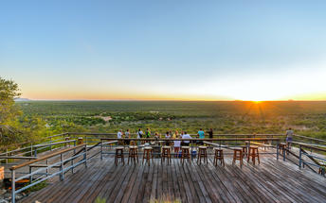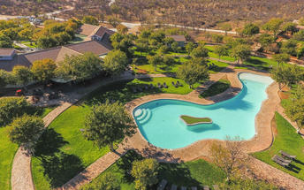

Standard Twin Room
Every room has its own garden, surrounded by a low wall. The rooms are spacious, have twin beds, and en suite bathrooms. All the rooms have air-conditioning and complimantary tea and coffee facilities. For family rooms, request rooms with interlead doors
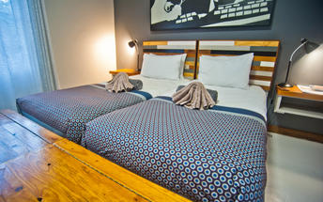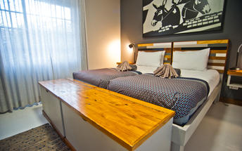

Basis
Bed and Breakfast

Day 6: Etosha Safari Camp Gondwana Collection Namibia, Etosha South

Etosha South
Located just south of the boundary of Etosha National Park in northwestern Namibia, Etosha South makes up the southern region of this wild paradise. Ongava Private Game Reserve shares the southern boundary with Etosha National Park and offers an array of luxury lodges overlooking picturesque landscapes dotted with abundant wildlife. The national park can be accessed via the southern entrance at Andersson’s Gate. Visitors can catch a glimpse of a variety of wildlife including: lion, giraffe, elephant, white and black rhino, and a multitude of plains game. Popular activities include: game drives, tracking rhinos on foot, guided nature walks, or watching the sunset over the magnificent African landscape.

Day Itinerary
After a relaxed breakfast, we travel towards the Etosha National Park, famous for its vast amount of wildlife. Once we have reached our camp located just outside of the National Park, we head onto our first safari into the National Park. Together with our guide we explore the various waterholes located close to Okaukuejo and the Anderson gate. Optional and time permitting open vehicle game drives can be booked with the lodge.

Overnight: Etosha Safari Camp Gondwana Collection Namibia View iBrochure
Etosha Safari Camp is located 10 km south of Andersson Gate on the C 38 (Etosha National Park).
Tap toes to an African beat in the novel Oshebeena Bar and relax at this friendly Camp, 10 kilometres from Etosha National Park. 50 chalets, shaded by mopane trees, and a grassy campsite provide a comfortable home from which to explore the abundant animal kingdom. Legendary.
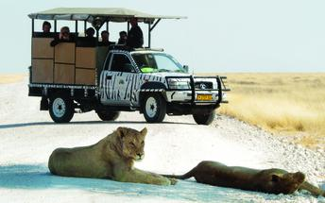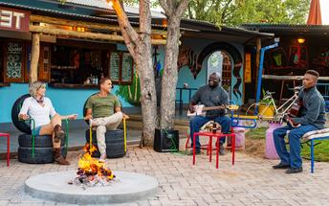

Standard Twin Rooms
The rooms are nested amongst Mopane trees.
Each room has twin beds, en suite bathroom (shower), air-conditioner and a small veranda.
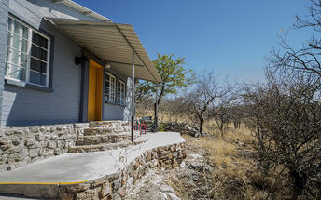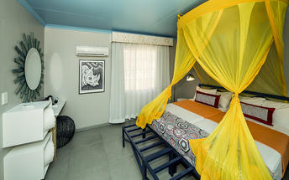

Basis
Bed and Breakfast

Day 7: Mokuti Etosha Lodge, Etosha East

Etosha East
Located in Northwestern Namibia, Etosha East is a protected sanctuary in the eastern part of the world-renowned Etosha National Park, known as one of the most accessible game reserves in Southern Africa. Etosha East boasts vast open plains scattered with semi-arid savannah grasslands dotted with watering holes and secluded bush camps. An impressive 5000-square-kilometre Etosha salt pan makes up a large area of the eastern side of the park and can even be seen from space. This remote area teems with abundant wildlife such as lions, elephants, black rhinos and giraffes, as well as a variety of birdlife featuring flamingos, ostriches, eagles, hornbills, and owls.

Day Itinerary
The day is devoted purely to the abundant wildlife found in the Etosha National Park, which surrounds a parched salt desert known as the Etosha Pan. The park is home to 4 of the Big Five - elephant, lion, leopard and rhino. The Park was proclaimed as Namibia’s first conservation area in 1907 by the then Governor, von Lindequist. Despite the size of the Etosha National Park, only the southern edge of the pan is accessible to visitors. Game viewing in the park is largely focussed around the waterholes, some of which are spring fed and some supplied from a borehole, ideal places to sit and watch over 114 different game species, or for an avid birder, in excess of 340 bird species. Popular game species such as giraffe, blue wildebeest, plains and mountain zebra, hyena, lion, leopard, antelopes such as kudu, oryx, eland, as well as some of the endangered species such as Black rhino, cheetah and the black-faced impala are all found here. An extensive network of roads link the over 30 water holes allowing visitors the opportunity of an extensive game viewing safari over the stretch of the park as each different area will provide different encounters.

Overnight: Mokuti Etosha Lodge View iBrochure
Mokuti Etosha Lodge is the perfect venue for travellers wanting to explore the famous eastern side of Etosha National Park and is located on its own private 4 000 hectare nature reserve, which shares a common border with this impressive wildlife reserve. Known for its excellent and diverse wildlife encounters, it has become a popular venue for meetings, incentives, weddings and honeymoons. This intimate lodge has 90 rooms and 16 luxury rooms. Recently refurbished, they are all air conditioned and come equipped with satellite TV, a mini-fridge, safes, free Wi-Fi, tea/coffee-making facilities and en-suite bathrooms. The lodge also offers the Tambuti Dining Room and Marula Bar, the Pool Bar and Terrace, two tennis courts, a spa, a gym and the only open air African Boma in the area.
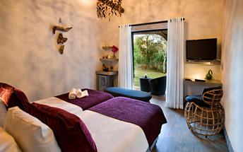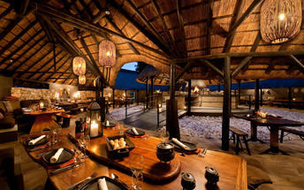

Standard Room
Can accommodate max 2 adults & child in cot only. All rooms feature en-suite bathroom with shower, air conditioning, electronic door lock, hair dryer, room safe, telephone, LCD television with satellite TV, Tea/coffee station, mini-fridge, free Wi-Fi.

Basis
Bed and Breakfast

Day 8: Mokuti Etosha Lodge, Etosha East

Day Itinerary
Today your guide again takes you on a game drive in the Etosha National Park, or optionally you can book an open game drive park drive with the lodge. We may encounter animal species we have not seen the previous day and look forward to any new surprises at the different waterholes visited. The Etosha Pan dominates the park. This salt pan desert, which is nearly completely enclosed by the park and is lined by numerous watering holes, is roughly 130 km long and as wide as 50 km in places. During Etosha’s notorious dry spells the pan is a deathly place, lying parched and cracked under the molten African sun. It is claimed that game viewing is best during the dry spells as animals will then congregate closer to water. But even in the rainy season the park remains an abundant wildlife haven. You then have the pleasure of experiencing the rebirth of life as the young foals, cubs and chicks are seen frolicking with their parents and the sprouting new green shrubs and grasses create a pleasing green oasis. In the afternoon we travel back to our lodge, where we enjoy the rest of the evening at leisure.

Basis
Bed and Breakfast

Day 9: End of Itinerary

Day Itinerary
After breakfast we travel back through the centre of the country exposing bushland savannah to the capital in the centre of the country. Time permitting, en-route we may stop at the famous wood carvers’ market in Okahandja or the craft market in the main street in Windhoek to pick up a last few souvenirs. Windhoek is a cosmopolitan melting pot of European architecture with African culture, with a variety of good restaurants to choose from. You will be dropped off at your accommodation of choice, or transferred to the airport for your outward flight.

Basis
Bed and Breakfast

Transport

Transfers
Date | Company | Pick Up | Drop Off | Time | Vehicle
 |  | Windhoek City | Elegant Desert Lodge |  | Transfer
 |  | Elegant Desert Lodge | Hansa Hotel |  | Transfer
 |  | Hansa Hotel | Damara Mopane Lodge Gondwana Collection Namibia |  | Transfer
 |  | Damara Mopane Lodge Gondwana Collection Namibia | Etosha Safari Camp Gondwana Collection Namibia |  | Transfer
 |  | Etosha Safari Camp Gondwana Collection Namibia | Mokuti Etosha Lodge |  | Transfer
 |  | Mokuti Etosha Lodge | Hosea Kutako International Airport [WDH] |  | Transfer

Urgent Contact Numbers
Company Name | Telephone | Email Address | Contact Person
Adventure To Africa | 1 703/665-1969 | info@adventuretoafrica.com | Poldi

Service Provider Directory
Service Provider | Ref. Number | Telephone | Address
Damara Mopane Lodge Gondwana Collection Namibia |  | +264 61 42 7200 | Damara Mopane Lodge  Khorixas Region
Elegant Desert Lodge |  | +264 63 29 3253 | C19Sesriem9000
Etosha Safari Camp Gondwana Collection Namibia |  | +264 61 42 7200 | Etosha Safari Camp  Outjo Region
Hansa Hotel |  | +264-64-414200 | 3 Hendrik Witbooi StreetSwakopmund9000
Mokuti Etosha Lodge |  | +264 67 22 9084

